**.What is Business Process Modelling?**

A Visual Way to Represent how an Organisation Perform

Work and service.

Business Model Represent Current Status, Define Future status And Identify Gap.

**. Capture Process.**

**. Provide Visual Representation.**

**. Identify What`s Needed.**

* **The Four Types Modelling Business Process Tools are as follow :**

**1.**

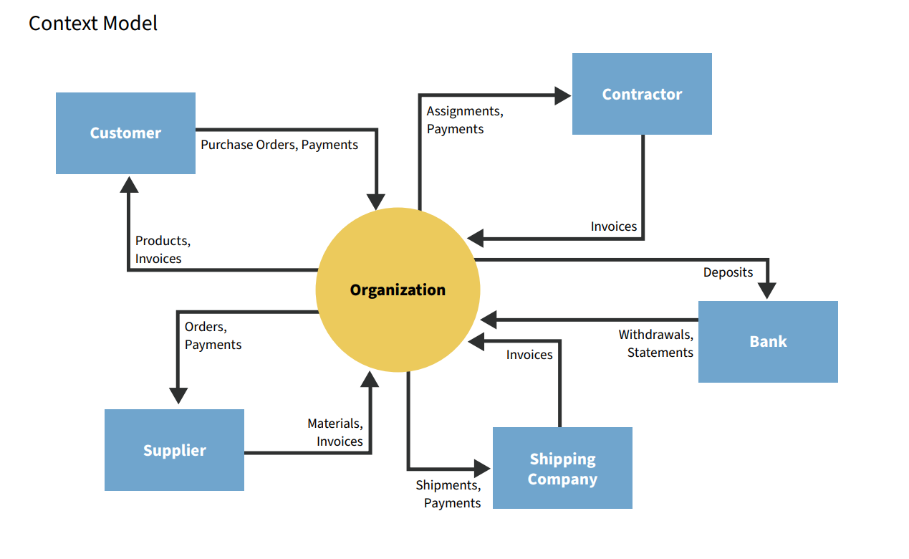

**Context Model Capture Relationship inputs and output It Help your Organization understand, What is needed by External Entity Relationship to Delivered Product and Service to Customers.**

**2.**

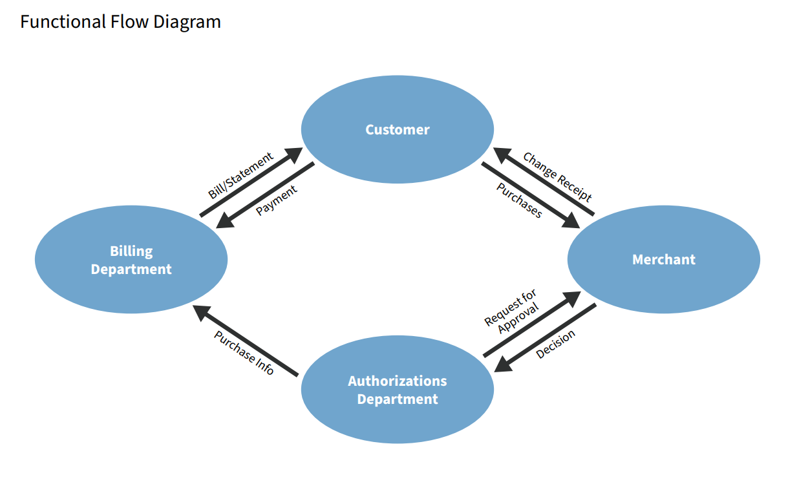

**The FFBD notation was developed in the 1950s, and is widely used in classical systems engineering. FFBDs are one of the classic business process modelling methodologies, along with flow charts, data flow diagrams, control flow diagrams, Gantt charts, PERT diagrams, and IDEF.**

**Function Flow Diagram Shows Internal Areas in your Organisation and how they interact in the overall origination.**

**Focus on single interaction between external entity and the organisation.**

**. Function Flow Diagram can be used:**

**. Target Audience.**

**. Validate Stakeholders**

3.

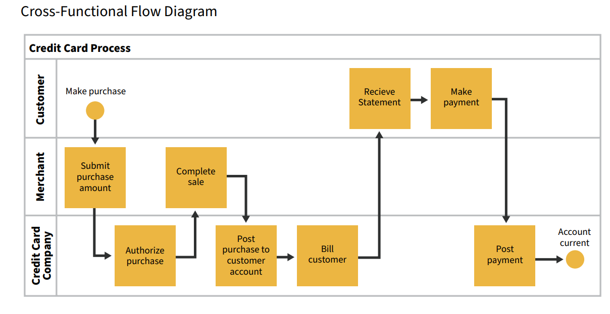

Cross Function Flow Diagram: Captures and orders activities performed by various stakeholders. It tells the story from start to end.

Complete End to End process of interaction of single transaction from initial customers trigger to delivery of items.

**. Cross Function can be used:**

**. Identify Break Down Complex Process.**

**. Identify Unnecessary Routine of work.**

**. Help to identify Inefficiencies.**

**This efficient tool brings clarity to processes by visualizing things. Users just need to take a glance at it to get the gist of the plan. Compared with the normal way where people have to spend hours listening to lengthy and complex presentations, this diagram is surely more effective in conveying cross-functional processes.**

4.

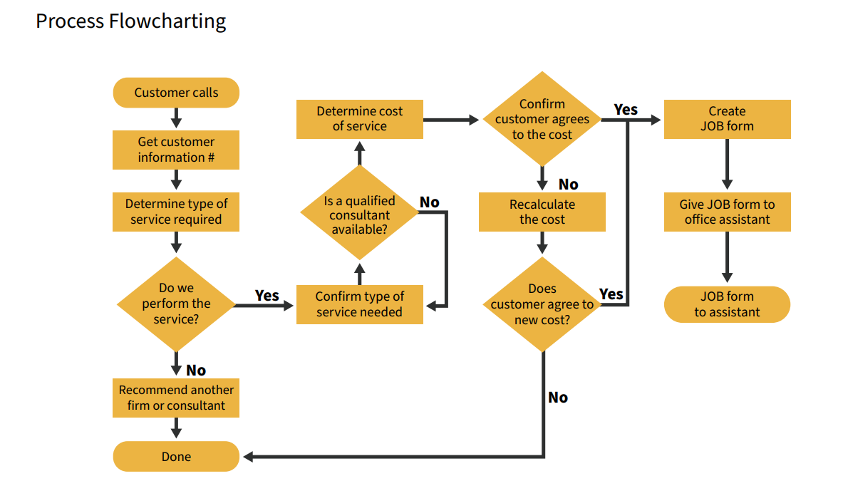

**The first structured method for documenting process flow, the "flow process chart", was introduced by Frank and Lillian Gilbreth in the presentation "Process Charts: First Steps in Finding the One Best Way to do Work", to members of the American Society of Mechanical Engineers (ASME) in 1921. The Gilbreths' tools quickly found their way into industrial engineering curricula. In the early 1930s, an industrial engineer, Allan H. Mogensen began to train business people in the use of some of the tools of industrial engineering at his Work Simplification Conferences in Lake Placid, New York.**

**Flow Charting: Each steps is Mapped out in Required Sequence, The most important part of flow chart diagram has ability to isolate each activities**

**Flow Charts Features:**

**. No interaction with other Function Area.**

**. Can flow in any Direction (According to Need)**